**Name: Ariel Gelman Date: 04/21/2018**

**Instructor: Professor Bahm**

**CRM DBMS Individual Response**

**What I accomplished on the BooksRUs CRM System project:**

I worked on the ERD, schema, database, design, data dictionary, and finally pieced together the database in Microsoft Azure. I created concepts for both the Entity Relationship Diagram and Schema trying to figure out how to create one solid integrated database for which all data revolved around the customer.

Like the other students in the class I had originally thought that the project had revolved around Store Sales and Inventory for which this was far from the case.

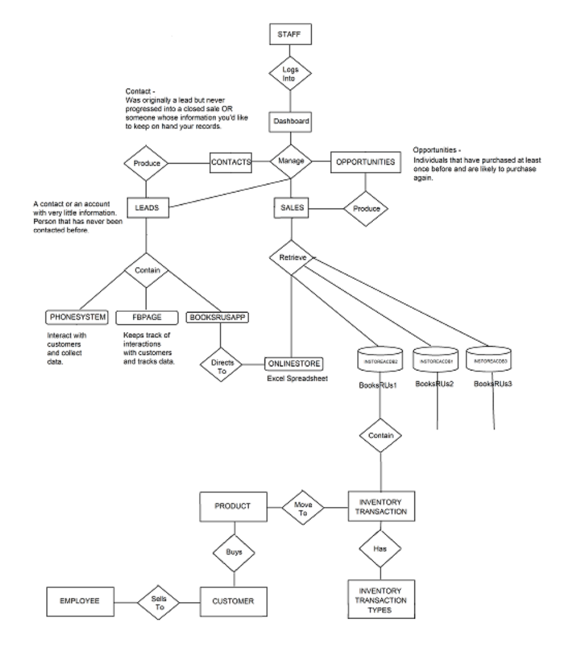

I had started with trying to figure out how the system would work and how each entity would be integrated into the overall system which was my primary challenge. I did not realize the importance to design and framework for the project until I started getting more involved in how each entity would play a role in my ERD.

The convenience of Microsoft Access’s ability to generate a table schema and ERD was not possible so I got to work creating drafts and revisions within a program called paint and slowly moved to an application called DBDesigner which allowed me to associate relationships among each table and add or remove fields with much more ease. My early ERD shows the three Microsoft Access Databases that I failed to think of in a unified manner until I got more in depth with the project. I started grasping onto the idea of being able to access any or customer data from one single table or just a few tables instead of everything being split up by in-store or online or wherever sales were taking place.

I can admit I got caught up in entering too much test data at first before verifying such things as referential integrity for which I also learned a valuable lesson. I did a lot of research on SalesForce CRM and others to get an accurate depiction of what I wanted to create for a Customer Relationship Management system. Some of the notable facts I learned about a CRM were how valuable Opportunities, Contacts, Leads, and Customer Sales information were to the system. Researching more in depth about these pieces of a typical CRM helped be create the necessary tables and fields such as my Sales Pipeline Stage. I integrated the concept of knowing my customers location as to be able to predict when or where an advertisement for a book should be displayed to try to produce sales (marketing campaign). I also found that ad for Petunia Pumping Prickle Pants on the BookRUs app to be another form of a Source Campaign for a Source Product (being that of the book). The more research I had done the more sense that everything finally made. Lab 8 of Advanced DBMS class taught me how valuable having a data dictionary was to refer to all my data types in making sure everything was defined accurately and accordingly throughout my tables so that referential integrity and cascading would work. I had done a lot of cross reference checks too between the data dictionary that I created and the database structure file that I created.

I learned that it was important to place junction tables in my schema so that CRM users can utilize drop down fields and select from a series of options held by check constraints (these fields then would not just be static).

I kept Notes using DBDesigner so that I could remember what data I would be collecting or what fields would use check constraints. I then integrated this into my data dictionary descriptions to make it easier to understand what was needed or being collected for each field if necessary.

Another helpful tip that I took advantage of was looking at the frontend application interface of many CRMs to see things that I might be missing. This led me to scour the Internet to see what more common CRM dashboards, input fields, and dropdown options would look like. I used MS paint not only to draw frond API concepts for the proposal but also for the final product. I knew a lot of the charts and graphs on the CRM dashboard I was creating would use statistics and other calculations from fields to generate what was needed (this can be seen if you reference the bar graphs or line graphs on the dashboard design).

I found that drawing the concept art in paint was very tedious and much would have rather preferred using a wireframe program for mockups – however I could not find a simple enough program to learn with the time restrictions.

When I was looking to accomplish the build of the CRM database in Microsoft Azure I also had acquired more knowledge on how transactions work. The example below I had to put together myself to get two separate tables to insert new values into respective fields in each record row at the same time. I needed this wrapped transaction, because of an identity column.

I also created a separate schema and ERD for the CRM User showing how security would work with designated roles for each position as a CRM user. This project had to be the largest I had worked on since I took leadership on a Systems Analysis and Design project when I attended community college.

BEGIN TRAN t2

DECLARE @Sale_ID BIGINT

INSERT Sales_Store1

VALUES (3, 3, '02-16-2002', 0.0, 'Check', NULL, 0.0, NULL)

SET @Sale_ID = SCOPE_IDENTITY()

INSERT Sales_Details_Store1

VALUES (@Sale_ID, 3, 4, 10.00, 0.0, '02-03-1992', 7)

COMMIT TRAN t2;

**How the CRM system works:**

The CRM user logs into the CRM Dashboard using a specified username and password combination where they can see all their leads, opportunities, sales, and contacts. The CRM user can work on trying to get leads from source campaigns to become contacts where they then try to keep in touch with the customer in hope of producing a sale. There is a specific Sales Pipeline Stage that must be followed through to close on an “opportunity” to produce a sale as seen in the final schema. The CRM user also may add additional contacts into the system as customer and see how many leads are being produced from campaign advertisements and marketing. Tasks can be generated or assigned as needed by the CRM user whose role may be different based on the entitlement or user role they have in the system giving them access to all or limited CRM resources. Everything revolving around the customer from where they work to their location is tracked in this CRM system. Lead locations show the tendency or frequently visited locations producing a trail that can be capitalized on for better marketing outreach. The theme of the system is to know your customer thoroughly and all their tendencies to produce a better relationship for sales growth.

**Final Note**

As the official team lead for the BooksRUs CRM Project I will note that communication was not adequate among team members as was promised during the project initiation phase. Often members did not attend class in which meetings could further be conducted and so additional progress could be made towards the completion of the project. I found that I did 90 percent of the work attributed to the success of this project (creating table structures with constraints, reinforcement of referential integrity, queries, reports, research, database schema, security, and ERD) as no status was communicated efficiently and on time. It was expressed within the contract that communication would be necessary at all times. I was available at any point in time for team members who had questions and for that which I did not know I referred to the instructor of the class.